**Cost-Effectiveness of School-Based Mass Drug Administration for Helminth Infections in High Prevalence Settings**

Selam Melese, Natalie Olson

HPM 573

**Abstract:**

Hookworm (Necator americanus and Ancylostoma duodenale) afflicts approximately 500 million people annually1, often resulting in severe anemia that can impact growth and development as well as educational attainment among children in endemic regions2. To combat this disease, mass drug administration using Albendazole is often implemented annually in these regions3. In order to determine whether semi-annual Albendazole mass drug administration (MDA) campaigns are a more cost-effective strategy for controlling hookworm infection than the current standard of annual school-based MDA campaigns, a Markov model was used to simulate a school-aged population in a high-transmission setting and generate cost-effectiveness analyses. According to this model, semi-annual MDA can decrease the average cumulative duration of infection among children and reduce the burden of disability-adjusted life-years (DALYs) attributable to hookworm infection but annual MDA remains a cost-effective strategy when available funds are limited.

**Background:**

Hookworm is a soil-transmitted helminth (STH) that persists environmentally in sub-tropical and tropical regions1. As seen in the life cycle diagram presented in Figure 1, the parasite’s eggs hatch after entering the environment through fecal transmission and infection occurs through oral ingestion or penetration of exposed skin by parasites in the L3 larval stage1. After migrating through the bloodstream to the heart, larvae undergo tracheal migration to the gastro-intestinal tract where adult hookworms develop within the human small intestine. In the small intestine, the adult hookworm feeds on the host’s blood, causing iron-deficiency anemia1 and down-regulating the host immune response to infection1. Hookworm is prevalent among children and adults in low- and middle-income countries; chronic hookworm infection during childhood can result in impaired cognitive function and stunted growth and development2.

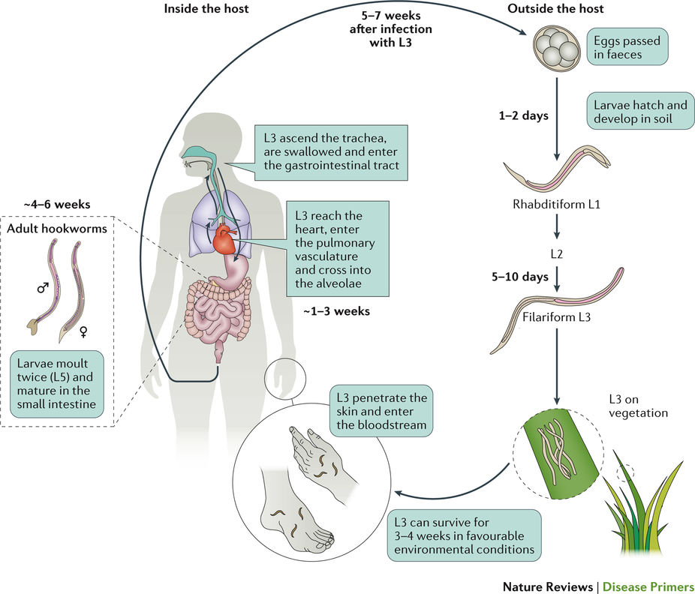

Fig. 1 Hookworm Life Cycle1

While improved sanitation and hygiene education are critical components in reducing hookworm morbidity4, the prevailing strategy in controlling hookworm parasitemia is anthelminthic mass drug administration(MDA)3. The current standard is to employ Albendazole MDA annually in high-risk populations5. Albendazole is a benzimidazole-based therapy that inhibits microtubule polymerization in invertebrate eukaryotes such as helminths, effectively killing adult hookworms1. Unfortunately, coverage rates are often less than 35% in endemic regions3 and the rate of re-infection with hookworm can be quite rapid given its reproductive rate estimated at 3.0**3** and the lack of adaptive immunity to hookworm infection; therefore, interventions should be planned with careful consideration of reinfection rates to optimize the reduction of DALYs attributable to hookworm infection. This model considers the comparative cost-effectiveness of annual MDA versus semi-annual MDA in reducing the burden of infection among school-aged children.

**Methods:**

Due to the complex natural history of hookworm, a number of simplifying assumptions have been made in developing this model. Our model assumes homogeneity of parameters among both the parasite and host populations. This includes a constant burden of parasitemia, which has been shown to vary between hosts3. Our model also makes significant assumptions in simplifying the parameters regarding the hookworm life cycle. Due to the nature of environmental transmission of hookworm, as well as the status of human adults as a reservoir population6, we assume a constant rate of environmental transmission among children that is not conditional on the proportion of infected individuals in the population being simulated. This assumption eliminates the need for SIR compartmental modeling and allows for the appropriate use of a Markov model in representing this population. The simulated population size remains constant, and we do not account for individuals entering and leaving the population (i.e. births and aging out of the simulated cohort); assuming that the birth rate remains constant, this assumption is reasonable.

Table 1. Parameters

|  |  |  |  |
| --- | --- | --- | --- |
| Parameter | Symbol | Rate | Reference |
| Transmission Rate | **𝜆1** | 6.5 per 100 person-years | Jiraanankul et al. 2011**7** | |
| Natural Recovery Rate | **𝜆4** | 1-4 years (2-year average) | Anderson et al. 20145 | |
| MDA Coverage Rate | **𝜆2** | 56.2% | Bartsch et al. 20163 | |
| Albendazole Effectiveness | **𝜆3** | 78.4% | Bartsch et al. 20163 | |
| Albendazole Treatment Cost | **-** | $0.50/child | Bartsch et al. 20163 | |
| DALY Estimate (Utility) | **-** | 0.802 | Bartsch et al. 20163 | |

In order to model the comparative cost-effectiveness of annual versus semi-annual MDA in a school setting, a Markov model was employed representing a school-aged population in a hookworm-endemic region. As depicted in Figure 2, the Markov model comprises three states: well (children not currently infected who are susceptible to infection), infected (children harboring hookworm parasites), and treatment (children currently undergoing an Albendazole medication regimen). Movement between these states occurs according to the rates determined from parameters in Table 1. The model reflects a population of one thousand simulated children who are all initially susceptible to infection and proceeds in weekly time steps for fifteen simulated years3. The model simulation provides an estimate of the decrease in cumulative infection duration for this population if MDA were employed semi-annually rather than annually; this represents successful reduction in the impact of hookworm on educational attainment and development.

**𝜆2**

**𝜆1**

**Receiving**

**Treatment**

**Well**

**(Susceptible)**

**Infected**

**𝜆4**

**𝜆3**

Fig. 2 Model States and Transitions

With the cost of treatment simulated at $0.50 per child, our cost-effectiveness analysis considers only the cost of medication, but not the added infrastructural costs of transportation to and from MDA distribution sites and community healthcare worker salaries. However, Albendazole is chemically stable at room temperature4 and therefore does not require cold-chain transportation, which often drives up costs of delivery to remote locations. We can therefore assume that MDA can be implemented within the infrastructural context of existing community health outreach programs and does not incur additional administrative costs to these programs. This parameter also does not account for productivity losses

Willingness-to-pay (WTP) per DALY was determined using the WHO recommended cost-effectiveness threshold of one to three times the gross domestic product (GDP) per capita of the country8. Using the per capita GDP of Brazil, the WTP per DALY for our model is set at $8,649.959.

Comparative economic evaluation was conducted using incremental net monetary benefit (NMB) analysis to visualize the cost-effectiveness of semi-annual MDA as an alternative to annual MDA at all values less than or equal to the maximum willingness-to-pay for each averted DALY. A cost-effectiveness plane was also generated with a cost-effectiveness frontier that indicated the comparative cost-effectiveness between semi-annual MDA and annual MDA.

Parameters were not directly calibrated in this model due to previously asserted assumptions that the population and transmission dynamics in the model are homogeneous. Calibration would be advisable if heterogeneity in transmission parameters were taken into consideration. The sensitivity of the parameter for cost was analyzed using a gamma distribution, and the sensitivity of utility was analyzed using a beta distribution. The discount rate was established using one-way sensitivity analysis. The sensitivity of the parameter for coverage rate was also tested, with comparisons made between a realistic coverage rate given by Bartsch et al. 20163 and an ideal coverage rate set by the World Health Organization 10.

**Results:**

According to the incremental net monetary benefit cost-benefit curve generated by our model, semi-annual MDA is a cost-effective alternative to annual MDA given the Incremental Net Monetary Benefit (NMB) generated by the model estimates <$400 per DALY averted, which is considerably less than the willingness-to-pay threshold of $8,649.95 per DALY averted11 (Fig. 9). This is also validated by the calculated ICER values of each strategy, which were $18.53/DALY for semi-annual MDA under normal conditions (56.2% coverage), $7.22/DALY for annual MDA under ideal conditions (75%), and $21.64/DALY for semi-annual MDA with ideal coverage (75%) (Table 2).

Under annual MDA, the average cumulative duration of infection was 0.94 years (95% CI: 0.89, 1.00). Semi-annual MDA decreased the average infection duration by 0.26 years (95% CI: 0.14, 0.39) and therefore decreased the average number of DALYs attributable to hookworm infection in the simulated population by 0.02 (95% CI: 0.01, 0.03). This alternative increased the average cost by $0.01 (95% CI: 0.01, 0.01) when compared with annual MDA. Cumulative duration of infection was somewhat sensitive to changes in coverage rate, with average expected cumulative duration of infection increasing among patients in both annual and semi-annual MDA strategy simulations in response to increased coverage rates.

Table 2. Calculation of Costs, DALYs, and ICERs

|  |  |  |  |
| --- | --- | --- | --- |
|  | Cost (2015 US$) | Total Disability (DALY) | ICER (US$/DALY Averted) |
| Annual, MDA 56.2% coverage | $281.00 | 30.33438642 | N/A |
| Annual, MDA 75% coverage | $375.00 | 17.3141475 | $7.22 |
| Semi-Annual, MDA 56.2% coverage | $562.00 | 15.16719321 | $18.53 |
| Semi-Annual, MDA 75% coverage | $750.00 | 8.65707375 | $21.64 |

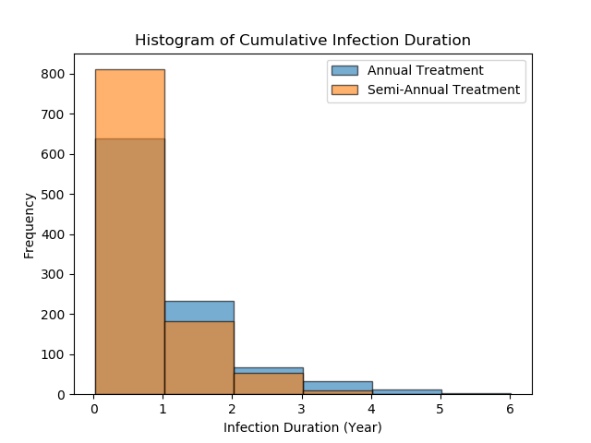

Figure 3. Histogram of cumulative infection duration

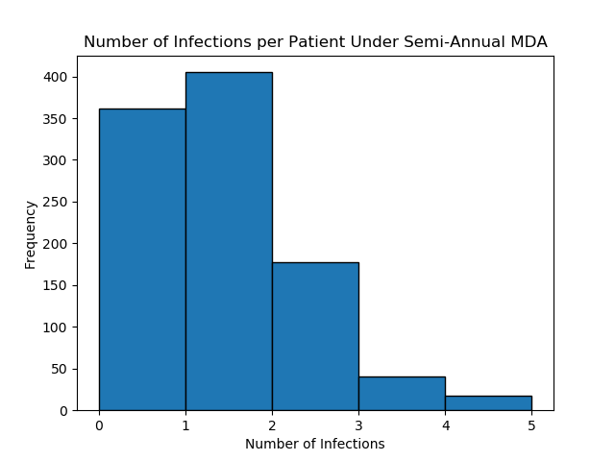

Figure 4. Histogram of number of infections per individual (Semi-Annual MDA)

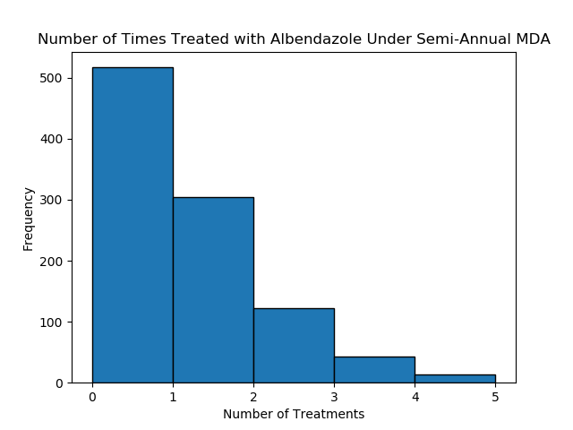

Figure 5. Histogram of number of infections treated (Semi-Annual MDA)

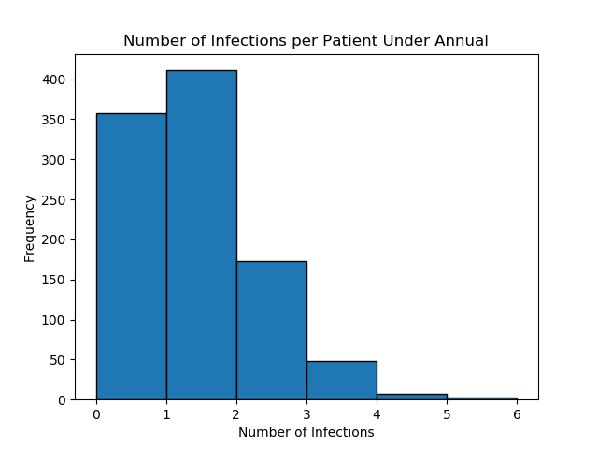

Figure 6. Histogram of number of infections per individual (Annual MDA)

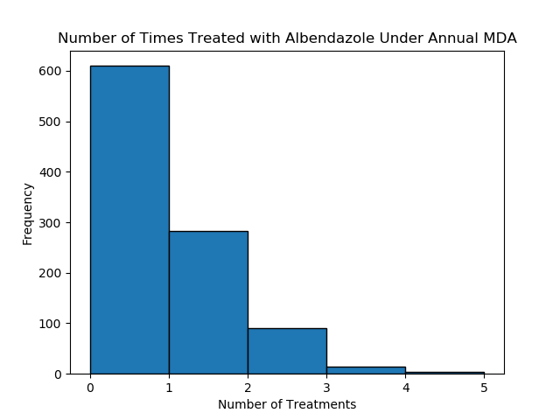

Figure 7. Histogram of number of infections treated (Annual MDA)

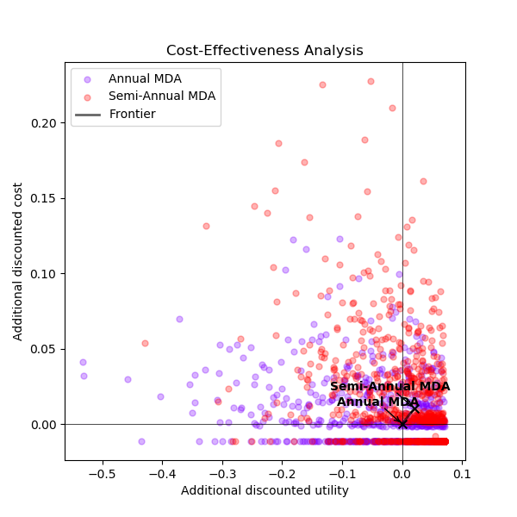

Figure 8. Cost-Effectiveness Analysis

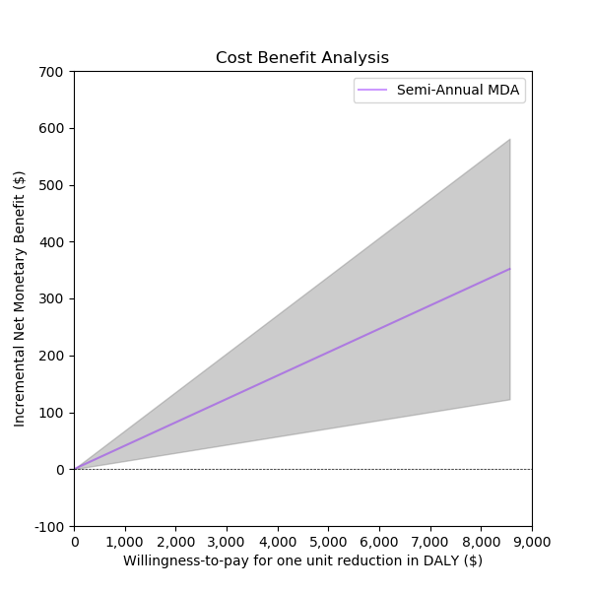

Figure 9. Incremental Net Monetary Benefit Analysis

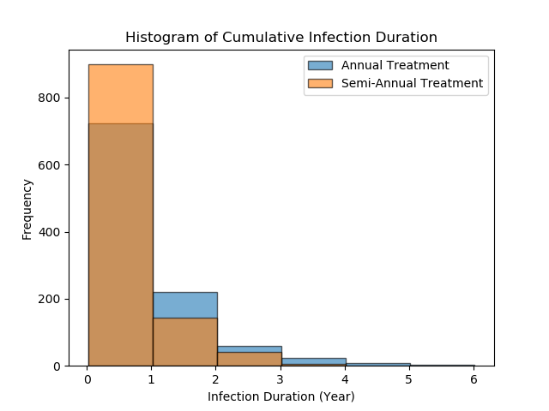

Figure 10. Histogram of cumulative infection duration given 75% coverage rate

**Discussion:**

As a result of the assumptions required for this model and the lack of calibration to establish validity of the model, conclusions drawn from model outputs are quite limited in regard to generalizability. We cannot draw conclusions from the data regarding effects of MDA on environmental transmission or overall population transmission dynamics. Additionally, the results of this model do not reflect the true heterogeneity in parasite burden and iron-deficiency anemia among children.

The decreased cumulative duration of infection under semi-annual MDA is a promising result in regard to the potential for DALY reduction and improvement in educational outcomes. Given that the average child under semi-annual MDA experiences hookworm infection for a total of 3.12 months less than the average child under annual MDA, this estimate of time spent infected could be used as a proxy for reduced exposure to the harmful effects of iron-deficiency anemia on development and educational attainment.

If the WHO goal of a 75% anthelminthic MDA coverage rate10 is met, the average duration of infection are estimated to be reduced for both annual and semi-annual MDA schemes (Fig. 10).

According to this model, semi-annual MDA is a cost-effective alternative to annual MDA in controlling the hookworm infection rates of a school-aged population (Fig. 8, Fig.9). However, semi-annual MDA does not dominate annual MDA on the cost-effectiveness plane (Fig. 8); therefore, both annual and semi-annual MDA are cost-effective strategies depending upon the resources available. For scenarios in which semi-annual MDA is feasible and affordable, it offers the benefit of improved utility over annual MDA. However, when funds or infrastructure are limited, annual MDA can provide a more affordable alternative.

It would be beneficial to develop a model that better approximates the transmission dynamics of hookworm infection in a community in order to more accurately represent and compare the cost-effectiveness of various MDA strategies. It would also be of interest to compare cost-effectiveness of standard MDA strategies with more sustainable alternatives such as water, sanitation, and hygiene (WASH) interventions12,13.

**References:**

1. Loukas A, Hotez PJ, Diemert D, Yazdanbakhsh M, McCarthy JS, Correa-Oliveira R, Croese J, Bethony JM. Hookworm infection*.* Nature Reviews Disease Primers 2016;2:16088.

2. Brooker S, Bethony J, Hotez PJ. Human Hookworm Infection in the 21(st) Century*.* Advances in parasitology 2004;58:197-288.

3. Bartsch SM, Hotez PJ, Hertenstein DL, Diemert DJ, Zapf KM, Bottazzi ME, Bethony JM, Brown ST, Lee BY. Modeling the economic and epidemiologic impact of hookworm vaccine and mass drug administration (MDA) in Brazil, a high transmission setting*.* Vaccine 2016;34:2197-206.

4. Jia T-W, Melville S, Utzinger J, King CH, Zhou X-N. Soil-Transmitted Helminth Reinfection after Drug Treatment: A Systematic Review and Meta-Analysis*.* PLOS Neglected Tropical Diseases 2012;6:e1621.

5. Anderson R, Truscott J, Hollingsworth TD. The coverage and frequency of mass drug administration required to eliminate persistent transmission of soil-transmitted helminths*.* Philosophical Transactions of the Royal Society B: Biological Sciences 2014;369:20130435.

6. Njenga SM, Mwandawiro CS, Muniu E, Mwanje MT, Haji FM, Bockarie MJ. Adult population as potential reservoir of NTD infections in rural villages of Kwale district, Coastal Kenya: implications for preventive chemotherapy interventions policy*.* Parasites & Vectors 2011;4:175.

7. Jiraanankul V, Aphijirawat W, Mungthin M, Khositnithikul R, Rangsin R, Traub RJ, Piyaraj P, Naaglor T, Taamasri P, Leelayoova S. Incidence and Risk Factors of Hookworm Infection in a Rural Community of Central Thailand*.* The American journal of tropical medicine and hygiene 2011;84:594-8.

8. Leech AA, Kim DD, Cohen JT, Neumann PJ. Use and Misuse of Cost-Effectiveness Analysis Thresholds in Low- and Middle-Income Countries: Trends in Cost-per-DALY Studies*.* Value in Health 2018.

9. GDP Per Capita (Current US $)*.* 2016.

10. Anderson RM, Turner HC, Truscott JE, Hollingsworth TD, Brooker SJ. Should the Goal for the Treatment of Soil Transmitted Helminth (STH) Infections Be Changed from Morbidity Control in Children to Community-Wide Transmission Elimination? PLOS Neglected Tropical Diseases 2015;9:e0003897.

11. Meyer-Rath G, van Rensburg C, Larson B, Jamieson L, Rosen S. Revealed willingness-to-pay versus standard cost-effectiveness thresholds: Evidence from the South African HIV Investment Case*.* PLoS ONE 2017;12:e0186496.

12. Ziegelbauer K, Speich B, Mäusezahl D, Bos R, Keiser J, Utzinger J. Effect of sanitation on soil-transmitted helminth infection: systematic review and meta-analysis*.* PLoS medicine 2012;9:e1001162.

13. Strunz EC, Addiss DG, Stocks ME, Ogden S, Utzinger J, Freeman MC. Water, sanitation, hygiene, and soil-transmitted helminth infection: a systematic review and meta-analysis*.* PLoS medicine 2014;11:e1001620.